Software Design Document

Diabetes Care

By

**Jirayu Chinpongsuwan 552115011**

Department of Software Engineering

College of Arts, Media and Technology

Chiang Mai University

_________________________________________________

**Project Advisor**

Dr. Prompong Sugunnasil

**Document History**

|  |  |  |  |  |  |  |
| --- | --- | --- | --- | --- | --- | --- |
| **Document Name** | **Version** | **Status** | **Date** | **Viewable** | **Reviewer** | **Responsible** |
| Document |  | | | | | |
| diabetes -SDD-V.0.1.docx | Add : Chapter One Introduction.  Add: Chapter Two System Architecture. | Draft | February  29, 2016 | JC, PS | JC, PS | JC, PS |
| diabetes -SDD-V.0.1.docx | Add: Chapter three Detailed Design.  Add: class diagram.  Add: Sequence diagram. | Draft | April 25,2016 | JC, PS | JC, PS | JC, PS |
| diabetes -SDD-V.0.1.docx | Add: Chapter Four Data Architecture  Add: Database Design | Draft | July  12,2016 | JC, PS | JC, PS | JC, PS |
| diabetes -SDD-V.0.1.docx | Update : Class diagram  Update: Sequence diagram | Draft | July  20,2016 | JC, PS | JC, PS | JC, PS |
| diabetes -SDD-V.0.2.docx | Update : Class diagram  Update: Sequence diagram  Update: Database design | Release | November  3,2016 | JC, PS | JC, PS | JC, PS |

*PS: Dr. Prompong Sugunnasil

*JC: Mr. Jirayu Chinpongsuwan

Table Content

Chapter One | 4.1 Introduction 6

4.1.1 Document Purpose 6

4.1.2 Software Scope 6

4.1.3 Definitions, Acronyms, and Abbreviations 7

4.1.4 User characteristic 7

4.1.5 Design Constraints 7

Chapter Two | 4.2 System Architecture 8

Chapter Three | 4.3 Detailed Design 9

4.3.1 Class Diagram Description 10

4.3.1.1 CD01: AcountController 10

4.3.1.2 CD02: ManageController 13

4.3.1.3 CD03: AdminController 14

4.3.1.4 CD04: FoodController 16

4.3.1.5 CD05: ExercisesController 17

4.3.1.6 CD06: RegisterViewModel 18

4.3.1.7 CD07: UserProfileInfoModel 20

4.3.1.8 CD08: UserAddressModel 22

4.3.1.9 CD09: EpandedUserDTO 23

4.3.1.10 CD10: ChangePassword 24

4.3.1.11 CD11: ExercisesModel 25

4.3.1.12 CD12: FoodModel 26

4.3.1.13 CD13: LogiViewModel 27

4.3.1.14 CD14: MedicineModel 28

4.3.1.15 CD15: TodayFoodModel 29

4.3.1.16 CD16: UserFoodModel 30

4.3.1.17 CD17: UserGlycemicModel 31

4.3.1.18 CD18: UserComplication 32

4.3.1.19 CD19: RolesDTO 33

4.3.1.20 CD20: UserRolesDTO 34

4.3.2 SequenceDiagram 35

4.3.2.01 SD01 Registration 35

4.3.2.02 SD02 Login 36

4.3.2.03 SD03 Log out 37

4.3.2.04 SD04 View profile 37

4.3.2.05 SD05 Edit user profile 38

4.3.2.06 SD06 Change password 39

4.3.2.07 SD07 Create new food 40

4.3.2.08 SD08 Edit food 41

4.3.2.09 SD09 Delete food 42

4.3.2.10 SD10 Add activity 43

4.3.2.11 SD11 Edit activity 44

4.3.2.12 SD12 Delete activity 45

4.3.2.13 SD13 Admin create new user 46

4.3.2.14 SD14 Admin edit user 47

4.3.2.15 SD15 Delete user 47

4.3.2.16 SD16 Add food to healty plan 48

4.3.2.17 SD17 Delete food to healty plan 48

4.3.2.18 SD18 View BMI 49

4.3.2.19 SD19 Add blood sugar 49

4.3.2.20 SD20 View blood sugar graph 50

4.3.2.21 SD21 Get recommend 51

4.3.3 User Interface 52

Chapter Four | 4.4 Data Architecture 62

4.4.1 Entity Relationship Diagram 62

4.4.2 Database Design 65

# Chapter One | 4.1 Introduction

## 4.1.1 Document Purpose

The Software Design Document (SDD) is a document used to establish architecture of Diabetes web application, compose of the high level of software design, system architecture, database system and graphic user interfaces. The document is purpose to describe the overall system design and detail in each part of functional design. The SDD is importance thing so that it is the blueprint of system that provided to be explicit understanding between developers.

## 4.1.2 Software Scope

Software Design Document is the document use to explain overall design architecture of the Diabetes web application. This document covers content about

**- User Characteristic**

The user characteristic is the information explaining about activity that user can interact and perform with the application.

**- Constrains**

The project constrains is the information describe about a limit of application that might have effect with user.

**- System Architecture**

The system Architecture is the information about overall architecture of an application system.

**- Detailed Design**

The detail design is the information describes each detail of design architecture within the application system.

**- Data Architecture**

The data architecture is the information about overall data property which use in the application.

**- User Interface Design**

The user interface design is the information about overall design interface of the application.

## 

## 4.1.3 Definitions, Acronyms, and Abbreviations

* **Key Definitions**

**Diabetes**  Name of this project

**System** “Computer programs, procedure and associated documentation and data pertain to the operation of a computer system” [IEEE90]

**Database** A collection of logically related data stored together in one or more computerized files. [IEEE90]

* **Key Acronyms and Abbreviation**

**SDD**  Software design document

**SD** Sequence diagram

**UI**  User interface

**ID** Identity number

**CD** Class diagram

## 4.1.4 User characteristic

User: User can direct access an application via their desktop, tablets, and phones to every part of this application by requesting internet connection. The patient is the person who can create a health plan and monitor nutrition behavior for preventing theirs from the complications disease. Admin is the person who can manage the account of doctor, nurse, and nutritionists. Doctor/Nurse is the person who can enter patient information into the system and management the activity in a part of insert/update/delete. And the nutritionist is the person who can control the nutrition in part of insert/update/delete.

## 4.1.5 Design Constraints

**Need PHP 5.5 platform or newer.**

Diabetes web application use MVC .Net platform on developing process. Therefore, user need any web browser for run this application.

# Chapter Two | 4.2 System Architecture

1111

**Figure 1: The architecture system of "Diabetes Care" web application**.

The “Diabetes Care Web Application” can run on the different platform (mobile web browser, PC web browser). The first part, database server stores the data of Diabetes application about the information of Patient, nutritionists and data of foods and activity. Second, The user who can send the request via a web browser to “Diabetes Care web application”. The application will request information from the database and return to the user.

# Chapter Three | 4.3 Detailed Design

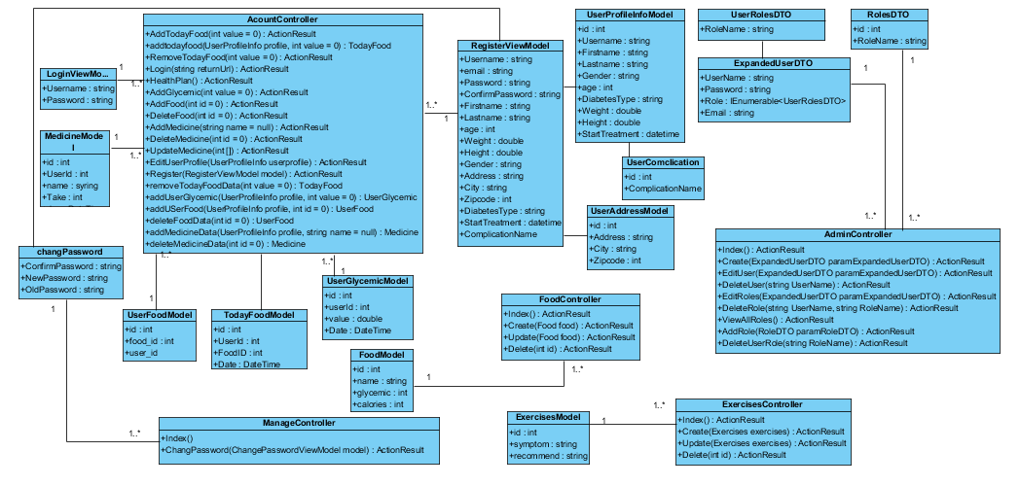

**Figure 2:** The High Level Design represents the relationship between UML Class Diagrams.

## 4.3.1 Class Diagram Description

### 4.3.1.1 CD01: AcountController

**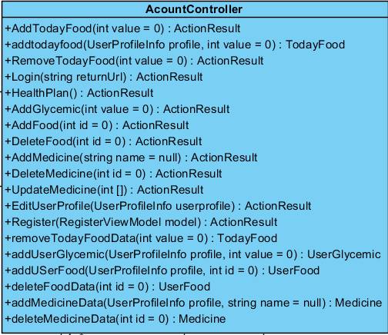  
Figure 3**: CD01: AccountController

**Description:** This class is a controller for the user to go to the login page for logging-in and logging-out, go to register page for registering, manage health plan, manage medicine of user, add glycemic for analyzing in a form of the graph, and user manage user profile.

**Method:**

|  |  |  |  |  |  |
| --- | --- | --- | --- | --- | --- |
| **ID** | **Name** | **Description** | **access modifiers** | **Parameter** | **Return Type** |
| 1 | AddTodyFood() | This method selects food from the food database and adds to table TodayFood.  And this method returns redirect to account page | public | int value = 0 | ActionResult |
| 2 | addtodayfood() | This method get list of food that the user eat to day when the user has input list of food. | public | UserProfileInfo profile, int value = 0 | TodayFood |
| If the user dose not input list of food. The system shall return null. |
| 3 | RemoveTodayFood() | This method selects food by id form table TodayFood and removes.  And this method returns redirect to account page. | public | int value = 0 | ActionResult |
| 4 | removeTodayFoodData() | This method get list of food that the user eat today when the user has input list of food. | public | int value = 0 | TodayFood |
| If the user dose not input list of food. The system shall return null. |
| 5 | Login() | This method get login and return redirect to login page. | public | string returnUrl | ActionResult |
| 6 | HealthPlan() | This method has to calculate BMI, BMR food glycemic, and food calorie.  And this method returns redirect to health plan page. | public | - | ActionResult |
| 7 | AddGlycemic() | This method adds value of glycemic index or blood sugar.  And this method returns redirect to health plan page. | public | int value = 0 | ActionResult |
| 8 | addUserGlycemic() | This method gets blood sugar value of user when the user has input blood sugar value. | public | UserProfileInfo profile,  int value = 0 | UserGlycemic |
| If the user dose not input blood sugar value. The system shall return null. |
| 7 | AddFood () | This method can select and add food on health plan page.  And this method returns redirect to health plan page. | public | int id = 0 | ActionResult |
| 8 | addUSerFood() | This method get list of food that the user need to inset to plan when the user has input food to list. | public | UserProfileInfo profile, int id = 0 | UserFood |
| If the user dose not input food. The system shall return null. |
| 9 | DeletFood() | This method can delete food on health plan page. return Redirect  And this method returns redirect to health plan page. | public | int id = 0 | ActionResult |
| 10 | deleteFoodData() | This method get list of food that the user need to delete from plan when the user has input food name. | public | int id = 0 | UserFood |
| If the user dose not input food name. The system shall return null. |
| 11 | AddMedicine() | This method can add his medicine to the system.  And this method returns redirect to display profile page | public | string name = null | ActionResult |
| 12 | addMedicineData() | This method gets list of medicine that the user inset to the system. When the user input medicine to list. | public | UserProfileInfo profile , string name = null | Medicine |
| If the user dose not input medicine. The system shall return null. |
| 13 | DeleteMedicine() | For user can delete his medicine.  And this method returns redirect to display profile page | public | int id = 0 | ActionResult |
| 14 | deleteMedicineData() | This method get list of medicine that the user need to delete when the user has input medicine. | public | int id = 0 | Medicine |
| If the user dose not input medicine. The system shall return null. |
| 15 | UpdateMedicine() | This method can edit/update his medicine.  And this method returns redirect to account index page. | public | int[] medicine = null | ActionResult |
| 16 | [HttpPost] Login () | This method login to the system.  And this method returns data which include object of LoginViewModel. | public | LoginViewModel model, string returnUrl | ActionResult |
| 17 | EditUserProfile() | This method can edit/update the user information on profile page.  And this method returns data which include object of UserProfileInfo. | public | UserProfileInfo userprofile | ActionResult |
| 18 | Register() | This method records the user info to the database. And this method returns data which include object of RegisterViewModel. | public | RegisterViewModel model | ActionResult |

**Table 1**: Method of CD01: AccountController

### 4.3.1.2 CD02: ManageController

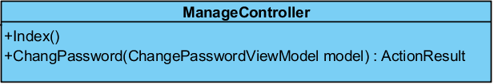

**Figure 4**: CD02: ManageController

**Description:** This class is controller for user to go to Index page that is first page of management page, change password is page for user need to change new password.

**Method:**

|  |  |  |  |  |  |
| --- | --- | --- | --- | --- | --- |
| **ID** | **Name** | **Description** | **Access modifiers** | **Parameter** | **Return Type** |
| 1 | Index() | This method defines the error message. | public | - | ActionResult |
| 2 | Change Password() | This method can change or manage password for login to the system.  And this method returns data which include object of ChangePawsswordViewModel. | public | ChangePasswordViewModel model | ActionResult |

**Table 2**: Method of CD02: ManageController

### 4.3.1.3 CD 03: AdminController

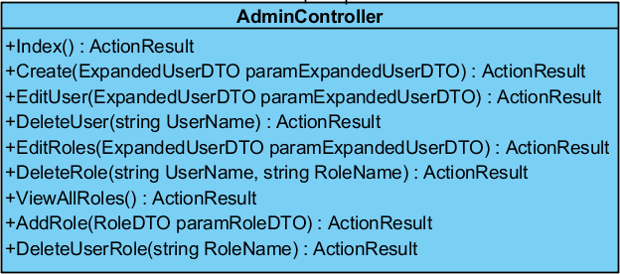

**Figure 5**: CD03: AdminController

**Description:** This class is controller for admin need to go to administration management page for manage the role of user account. Such as create new user account, update account, delete account, add role, edit role, delete role.

**Method:**

|  |  |  |  |  |  |
| --- | --- | --- | --- | --- | --- |
| **ID** | **Name** | **Description** | **Access modifiers** | **Parameter** | **Return Type** |
| 1 | Index() | This method returns data from the database. | public | - | ActionResult |
| 2 | Create() | This method can create new user account to the system.  This method returns data which include object of ExpandedUserDTO. | public | ExpandedUserDTO paramExpandedUserDTO | ActionResult |
| 3 | EditUser() | This method can update or edit user account in the system.  This method return data which include object of ExpandedUserDTO | public | ExpandedUserDTO paramExpandedUserDTO | ActionResult |
| 4 | DeleteUser() | This method can delete user from the system | public | string UserName | ActionResult |
| 5 | EditRole() | This method can delete nutritionists from the system.  This method returns data which include object of ExpandedUserDTO. | public | ExpandedUserDTO paramExpandedUserDTO | ActionResult |
| 6 | DeleteRole() | This method can delete role from the system.  Return data to edit role view. | public | string UserName, string RoleName | ActionResult |
| 7 | ViewAllRole() | This method can view name of all role. | public | - | ActionResult |
| 8 | AddRole() | This method can add role to the system.  This method returns data which include object of RoleDTO. | public | RoleDTO paramRoleDTO | ActionResult |
| 9 | DeleteUserRole() | This method can delete role of user account. | public | string RoleName | ActionResult |

**Table 3**: Method of CD03: AdminController

### 4.3.1.4 CD04: FoodsController

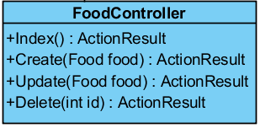

**Figure 6**: CD04: FoodsController

**Description:** This class is controller for nutritionists need to go to a nutritionists management page for manage the foods. Such as create new food, update food or delete food.

**Method:**

|  |  |  |  |  |  |
| --- | --- | --- | --- | --- | --- |
| **ID** | **Name** | **Description** | **Access modifiers** | **Parameter** | **Return Type** |
| 1 | Index() | This method display detail of food management.  This method returns redirect to index view. | public | - | ActionResult |
| 2 | Create() | This method can create new food to the system.  This method returns data which include object of Food. | public | Food food | ActionResult |
| 3 | Update() | This method can update or edit food in the system.  This method returns data which include object of Food. | public | Food food | ActionResult |
| 4 | Delete() | This method can delete food from the system.  This method returns redirect to index view. | public | int? id | ActionResult |

**Table 4**: Method of CD04: FoodsController.

### 4.3.1.5 CD05: ExercisesController

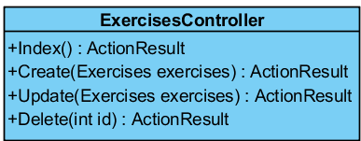

**Figure 7**: CD05: ExercisesController

**Description:** This class is controller for doctor/nurse need to go to activity management page for manage the activity. Such as create new activity, update activity or delete activity.

**Method:**

|  |  |  |  |  |  |
| --- | --- | --- | --- | --- | --- |
| **ID** | **Name** | **Description** | **Access modifiers** | **Parameter** | **Return Type** |
| 1 | Index() | This method display detail of exercises management.  This method returns redirect to index view. | public | - | ActionResult |
| 2 | Create() | This method can create new exercises list to the system.  This method returns data which include object of Exercises. | public | Exercises exercises | ActionResult |
| 3 | Update() | This method can update or edit exercises in the system.  This method returns data which include object of Exercises. | public | Exercises exercises | ActionResult |
| 4 | Delete() | This method can delete activity from the system.  This method returns redirect to index view. | public | int? id | ActionResult |

**Table 5**: Method of CD05: ExercisesController

**4.3.1.6 CD06: RegisterViewModel**

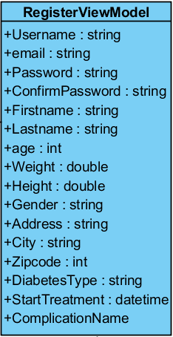

**Figure 8**: CD06: RegisterViewModel

**Description:** This class is class that inherits from class UserProfileInfoModel and class UserAddressModel. For extend model to correspond to table “Asp Net User” and “Address” in the database.

**Attribute:**

|  |  |  |  |  |
| --- | --- | --- | --- | --- |
| **ID** | **Name** | **Description** | **Access modifiers** | **Return Type** |
| 1 | Username | The attribute “Username” can contain a get accessor, a set accessor the Usernamedata on table “Asp Net User” in the database. | public | - |
| 2 | Email | The attribute “Email” can contain a get accessor, a set accessor the email data on table “Asp Net User” in the database. | public | - |
| 3 | Password | The attribute “Password” can contain a get accessor, a set accessor the password data on table “Asp Net User” in the database. | public | - |
| 4 | ConfirmPassword | The attribute “ConfirmPassword” can contain a get accessor, a set accessor the confirm password data on table “Asp Net User” in the database. | public | - |
| 5 | Firstname | The attribute “Firstname” can contain a get accessor, a set accessor the first name data on table “Asp Net User” in the database. | public | - |
| 6 | Lastname | The attribute “Lastname” can contain a get accessor, a set accessor the last name data on table “Asp Net User” in the database. | public | - |
| 7 | age | The attribute “age” can contain a get accessor, a set accessor the agedata on table “Asp Net User” in the database. | public | - |
| 8 | weight | The attribute “weight” can contain a get accessor, a set accessor the weight data on table “Asp Net User” in the database. | public | - |
| 9 | height | The attribute “height” can contain a get accessor, a set accessor the height data on table “Asp Net User” in the database. | public | - |
| 10 | gender | The attribute “gender” can contain a get accessor, a set accessor the gender data on table “Asp Net User” in the database. | public | - |
| 11 | address | The attribute “address” can contain a get accessor, a set accessor the address data on table “Address” in the database. | public | - |
| 12 | city | The attribute “city” can contain a get accessor, a set accessor the city data on table “Address” in the database. | public | - |
| 13 | Zipcode | The attribute “Zipcode” can contain a get accessor, a set accessor the city code data on table “Address” in the database. | public | - |
| 14 | DiabetesType | The attribute “DiabetesType” can contain a get accessor, a set accessor the diabetes type data on table “Asp Net User” in the database. | public | - |
| 15 | StartTreatment | The attribute “StartTreatment” can contain a get accessor, a set accessor the start treatment data on table “Asp Net User” in the database. | public | - |

**Table 6**: Method of CD06: RegisterViewModel

**4.3.1.7 CD07: UserProfileInfoModel**

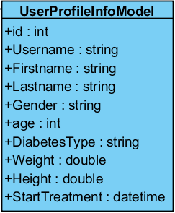

**Figure 9**: CD07:UserProfileInfoModel

**Description:** This class is extend model to correspond to table “Asp Net User” in the database

**Attribute:**

|  |  |  |  |  |
| --- | --- | --- | --- | --- |
| **ID** | **Name** | **Description** | **Access modifiers** | **Return Type** |
| 1 | id | The attribute “id” can contain a get accessor, a set accessor the data id of user info on table “Asp Net User” in the database. | public | - |
| 2 | Username | The attribute “Username” can contain a get accessor, a set accessor the Username data on table “Asp Net User” in the database. | public | - |
| 3 | Firstname | The attribute “Firstname” can contain a get accessor, a set accessor the first name data on table “Asp Net User” in the database. | public | - |
| 4 | Lastname | The attribute “Lastname” can contain a get accessor, a set accessor the last name data on table “Asp Net User” in the database. | public | - |
| 5 | age | The attribute “age” can contain a get accessor, a set accessor the agedata on table “Asp Net User” in the database. | public | - |
| 6 | weight | The attribute “weight” can contain a get accessor, a set accessor the weight data on table “Asp Net User” in the database. | public | - |
| 7 | height | The attribute “height” can contain a get accessor, a set accessor the height data on table “Asp Net User” in the database. | public | - |
| 8 | gender | The attribute “gender” can contain a get accessor, a set accessor the gender data on table “Asp Net User” in the database. | public | - |
| 9 | DiabetesType | The attribute “DiabetesType” can contain a get accessor, a set accessor the diabetes type data on table “Asp Net User” in the database. | public | - |
| 10 | StartTreatment | The attribute “StartTreatment” can contain a get accessor, a set accessor the start treatment data on table “Asp Net User” in the database. | public | - |

**Table 7**: Method of CD07: UserProfileInfoModel

**4.3.1.8 CD08: UserAddressModel**

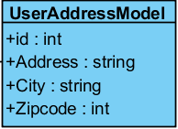

**Figure 10**: CD08:UserAddressModel

**Description:** This class is extend model to correspond to table “Address” in the database

**Attribute:**

|  |  |  |  |  |
| --- | --- | --- | --- | --- |
| **ID** | **Name** | **Description** | **Access modifiers** | **Return Type** |
| 1 | id | The attribute “id” can contain a get accessor, a set accessor the data id of user address on table “Address” in the database. | public | - |
| 2 | address | The attribute “address” can contain a get accessor, a set accessor the address data on table “Address” in the database. | public | - |
| 3 | city | The attribute “city” can contain a get accessor, a set accessor the city data on table “Address” in the database. | public | - |
| 4 | Zipcode | The attribute “Zipcode” can contain a get accessor, a set accessor the city code data on table “Address” in the database. | public | - |

**Table 8**: Method of CD08: UserAddressModel

**4.3.1.9 CD09: EpandedUserDTO**

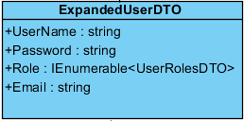

**Figure 11**: CD09:EpandedUserDTO

**Description:** This class is extend model to correspond to table “AdminManageUser” in the database

**Attribute:**

|  |  |  |  |  |
| --- | --- | --- | --- | --- |
| **ID** | **Name** | **Description** | **Access modifiers** | **Return Type** |
| 1 | UserName | The attribute “UserName” can contain a get accessor, a set accessor the data of username of user. | public | - |
| 2 | Password | The attribute “Password” can contain a get accessor, a set accessor the data of password of user . | public | - |
| 3 | Role | The attribute “Role” can contain a get accessor, a set accessor the data of role name from table role on the database | public | - |
| 4 | Email | The attribute “Email” can contain a get accessor, a set accessor the data of last name of user . | public | - |

**Table 9**: Method of CD09: EpandedUserDTO

**4.3.1.10 CD010: ChangePasswordModel**

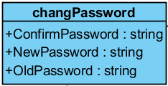

**Figure 12**: CD10:ChangePasswordModel

**Description:** This class is extend model to correspond to table “Asp Net User” in the database

**Attribute:**

|  |  |  |  |  |
| --- | --- | --- | --- | --- |
| **ID** | **Name** | **Description** | **Access modifiers** | **Return Type** |
| 1 | ConfirmPassword | The attribute “ConfirmPassword” can contain a get accessor, a set accessor the data of new password of user on table “Asp Net User” in the database. For validate new password and confirm password is same. | public | - |
| 2 | NewPassword | The attribute “NewPassword” can contain a get accessor, a set accessor the data of new password of user on table “Asp Net User” in the database. | public | - |
| 3 | OldPassword | The attribute “OldPassword” can contain a get accessor and set validate the data of current password of user on table “Asp Net User” in the database. | public | - |

**Table 10**: Method of CD10: ChangePasswordModel

**4.3.1.11 CD11: ExercisesModel**

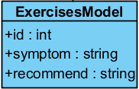

**Figure 13**: CD11:ExercisesModel

**Description:** This class is extend model to correspond to table “Activity” in the database

**Attribute:**

|  |  |  |  |  |
| --- | --- | --- | --- | --- |
| **ID** | **Name** | **Description** | **Access modifiers** | **Return Type** |
| 1 | id | The attribute “id” can contain a get accessor, a set accessor the data id of activity on table “Activity” in the database. | public | - |
| 2 | symptom | The attribute “symptom” can contain a get accessor, a set accessor the symptom data on table “Activity” in the database. | public | - |
| 3 | recommend | The attribute “recommend” can contain a get accessor, a set accessor the recommend data on table “Activity” in the database. | public | - |

**Table 11**: Method of CD12: ExercisesModel

**4.3.1.12CD12: FoodModel**

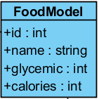

**Figure 14**: CD12:FoodModel

**Description:** This class is extend model to correspond to table “Food” in the database

**Attribute:**

|  |  |  |  |  |
| --- | --- | --- | --- | --- |
| **ID** | **Name** | **Description** | **Access modifiers** | **Return Type** |
| 1 | id | The attribute “id” can contain a get accessor, a set accessor the data id of food on table “Food” in the database. | public | - |
| 2 | name | The attribute “name” can contain a get accessor, a set accessor the data of name of food on table “Food” in the database. | public | - |
| 3 | glycemic | The attribute “glycemic” can contain a get accessor, a set accessor the data of glycemic of food on table “Food” in the database. | public | - |
| 4 | calories | The attribute “calories” can contain a get accessor, a set accessor the data of calories of food on table “Food” in the database. | public | - |

**Table 12**: Method of CD12: FoodModel

**4.3.1.13 CD13: LoginViewModel**

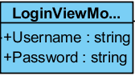

**Figure 15**: CD13:LoginViewModel

**Description:** This class is extend model to correspond to table “Asp Net User” in the database

**Attribute:**

|  |  |  |  |  |
| --- | --- | --- | --- | --- |
| **ID** | **Name** | **Description** | **Access modifiers** | **Return Type** |
| 1 | Username | The attribute “Username” can contain a get accessor, a set accessor the Username data on table “Asp Net User” in the database. For validate username. | public | - |
| 2 | Password | The attribute “Password” can contain a get accessor, a set accessor the data of password of user on table “Asp Net User” in the database. For validate password. | public | - |

**Table 13**: Method of CD013: LoginViewModel

**4.3.1.14 CD14: MedicineModel**

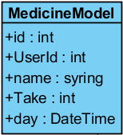

**Figure 16**: CD14:MedicineModel

**Description:** This class is extend model to correspond to table “Medicine” in the database

**Attribute:**

|  |  |  |  |  |
| --- | --- | --- | --- | --- |
| **ID** | **Name** | **Description** | **Access modifiers** | **Return Type** |
| 1 | id | The attribute “id” can contain a get accessor, a set accessor the data id of medicine on table “Medicine” in the database. | public | - |
| 2 | UserId | The attribute “UserId” can contain a get accessor, a set accessor the data id of user on table “Medicine” in the database. | public | - |
| 3 | name | The attribute “name” can contain a get accessor, a set accessor the data of name of medicine on table “Medicine” in the database. | public | - |
| 4 | Take | The attribute “Tale” can contain a get accessor, a set accessor the data on table “Medicine” in the database. | public | - |
| 5 | day | The attribute “day” can contain a get accessor, a set accessor the data of date of medicine on table “Medicine” in the database. | public | - |

**Table 14**: Method of CD14: MedicineModel

**4.3.1.15 CD15: TodayFoodModel**

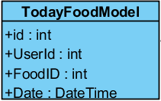

**Figure 17**: CD15:TodayFoodModel

**Description:** This class is extend model to correspond to table “TodayFood” in the database

**Attribute:**

|  |  |  |  |  |
| --- | --- | --- | --- | --- |
| **ID** | **Name** | **Description** | **Access modifiers** | **Return Type** |
| 1 | id | The attribute “id” can contain a get accessor, a set accessor the data id of today food on table “TodayFood” in the database. | public | - |
| 2 | UserId | The attribute “UserId” can contain a get accessor, a set accessor the data id of user on table “TodayFood” in the database. | public | - |
| 3 | FoodID | The attribute “FoodID” can contain a get accessor, a set accessor the data id of food from the table “Food” to table “TodayFood” in the database. | public | - |
| 4 | Date | The attribute “Date” can contain a get accessor, a set accessor the data of date on table “TodayFood” in the database. | public | - |

**Table 15**: Method of CD15: TodayFoodModel

**4.3.1.16 CD16: UserFoodModel**

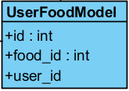

**Figure 16**: CD16:UserFoodModel

**Description:** This class is extend model to correspond to table “UserFood” in the database

**Attribute:**

|  |  |  |  |  |
| --- | --- | --- | --- | --- |
| **ID** | **Name** | **Description** | **Access modifiers** | **Return Type** |
| 1 | Id | The attribute “id” can contain a get accessor, a set accessor the data id of today food on table “UserFood” in the database. | public | - |
| 2 | user_id | The attribute “user_id” can contain a get accessor, a set accessor the data id of user on table “UserFood” in the database. | public | - |
| 3 | food_id | The attribute “food_id” can contain a get accessor, a set accessor the data id of food from the table “Food” to table “UserFood” in the database. | public | - |

**Table 16**: Method of CD16: UserFoodModel

**4.3.1.17 CD17: UserGlycemicModel**

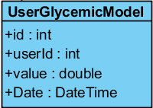

**Figure 19**: CD17: UserGlycemicModel

**Description:** This class is extend model to correspond to table “UserGlycemic” in the database

**Attribute:**

|  |  |  |  |  |
| --- | --- | --- | --- | --- |
| **ID** | **Name** | **Description** | **Access modifiers** | **Return Type** |
| 1 | Id | The attribute “id” can contain a get accessor, a set accessor the data id of glycemic index of user on table “UserGlycemic” in the database. | public | - |
| 2 | userId | The attribute “userId” can contain a get accessor, a set accessor the data id of user on table “UserGlycemic” in the database. | public | - |
| 3 | value | The attribute “value” can contain a get accessor, a set accessor the data of glycemic value on table “UserGlycemic” in the database. | public | - |
| 4 | Date | The attribute “Date” can contain a get accessor, a set accessor the data of date on table “UserGlycemic” in the database. | public | - |

**Table 18**: Method of CD18: UserGlycemicModel

**4.3.1.18 CD18: UserComplicationn**

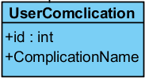

**Figure 20**: CD18: UserComplication

**Description:** This class is extend model to correspond to table “UserComplication” in the database

**Attribute:**

|  |  |  |  |  |
| --- | --- | --- | --- | --- |
| **ID** | **Name** | **Description** | **Access modifiers** | **Return Type** |
| 1 | id | The attribute “id” can contain a get accessor, a set accessor the data id of complication disease of user on table “UserComplication” in the database. | public | - |
| 2 | ComplicationName | The attribute “ComplicationName” can contain a get accessor, a set accessor the data name of complication disease on table “UserComplication” in the database. | public | - |

**Table 19**: Method of CD19: UserComplication

**4.3.1.19 CD19: RolesDTO**

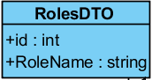

**Figure 21**: CD19: RolesDTO

**Description:** This class is extend model to correspond to table “AspRole” in the database

**Attribute:**

|  |  |  |  |  |
| --- | --- | --- | --- | --- |
| **ID** | **Name** | **Description** | **Access modifiers** | **Return Type** |
| 1 | id | The attribute “id” can contain a get accessor, a set accessor the data id of role on the database. | public | - |
| 2 | RoleName | The attribute “RoleName” can contain a get accessor, a set accessor the data name of role on the database. | public | - |

**Table 19**: Method of CD19: RolesDTO

**4.3.1.20 CD20: UserRole**DTO

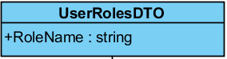

**Figure 22**: CD20: UserRoleDTO

**Description:** This class is extend model to correspond to table “UserComplication” in the database

**Attribute:**

|  |  |  |  |  |
| --- | --- | --- | --- | --- |
| **ID** | **Name** | **Description** | **Access modifiers** | **Return Type** |
| 1 | RoleNameDTO | The attribute “RoleName” can contain a get accessor, a set accessor the data name of role disease on the database. | public | - |

**Table 20**: Method of CD20: UserRoleDTO

# 4.3.2 Sequence Diagram

**4.3.2.1 SD01: Registration.**

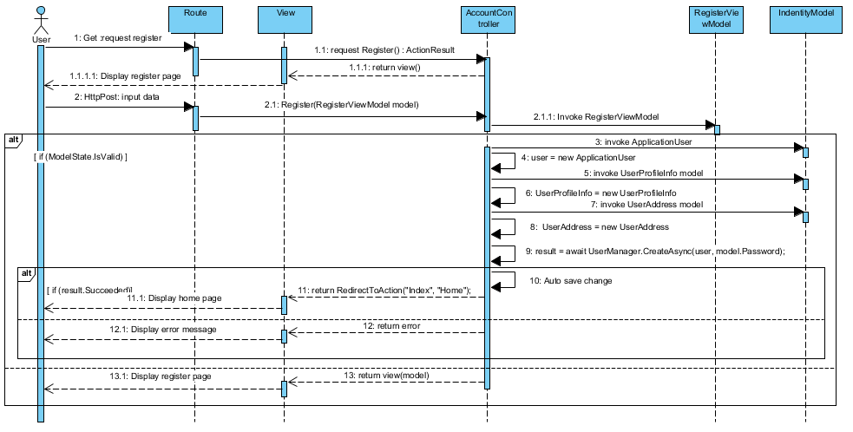

Figure 23: SD01: Registration.

# 4.3.2.2 SD02: Login.

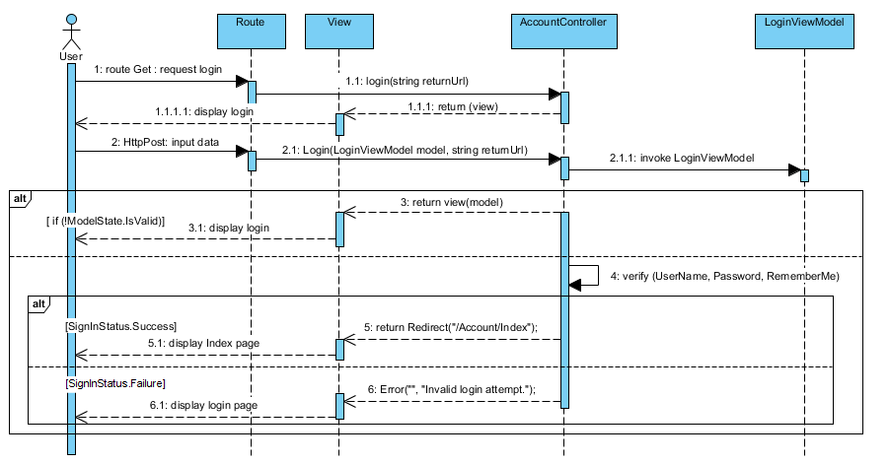

Figure 24: SD02: Login.

# 4.3.2.3 SD03: Logout.

# C:\Users\DELL\Desktop\project\diagram\sdsd\3.PNG

Figure 25: SD03: Logout.

# 4.3.2.4 SD04: View user profile.

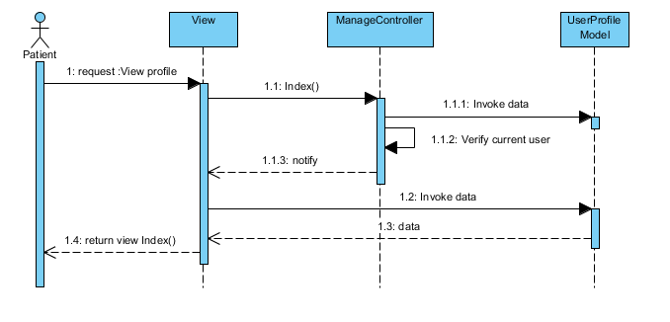

Figure 26: SD04: View user profile.

# 4.3.2.5 SD05: Edit user profile.

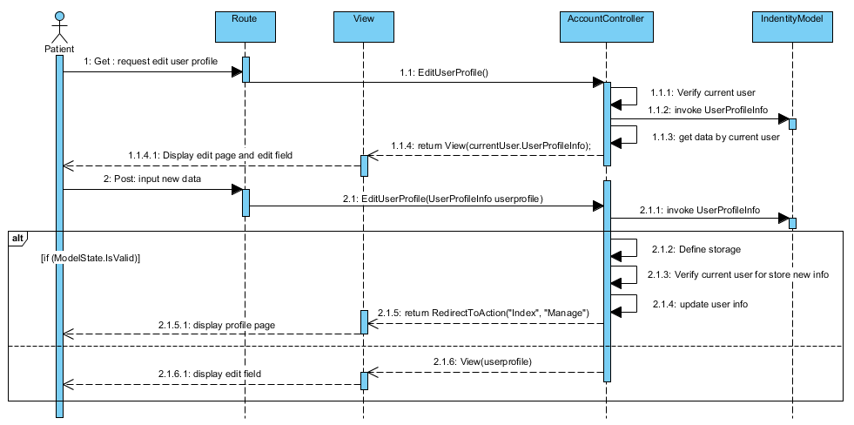

Figure 27: SD05: Edit user profile.

# 4.3.2.6 SD06: Change password

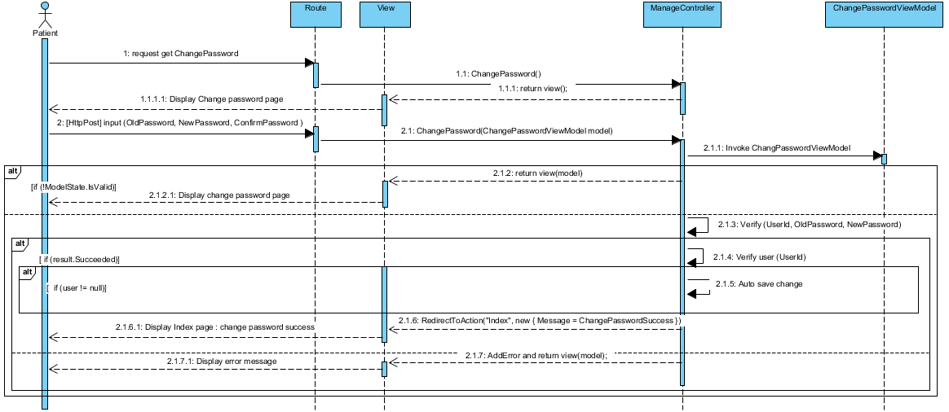

Figure 28: SD06: Change password

# 4.3.2.7 SD07: Create new food

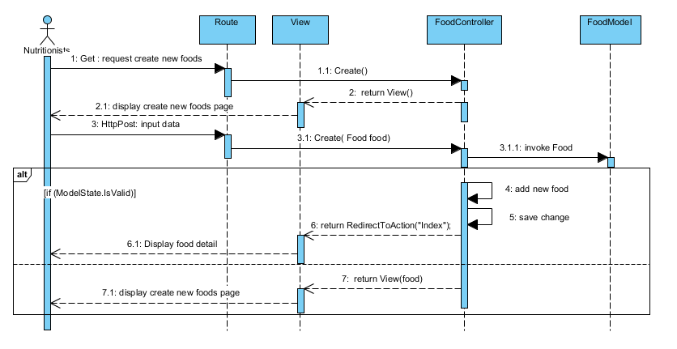

Figure 29: SD07: Create new food

# 3.2.8 SD08: Edit food info

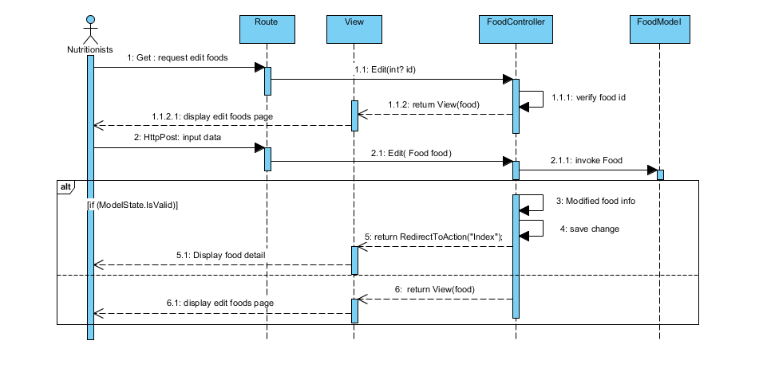

Figure 30: SD08: Edit food info

# 4.3.2.9 SD09: Delete food

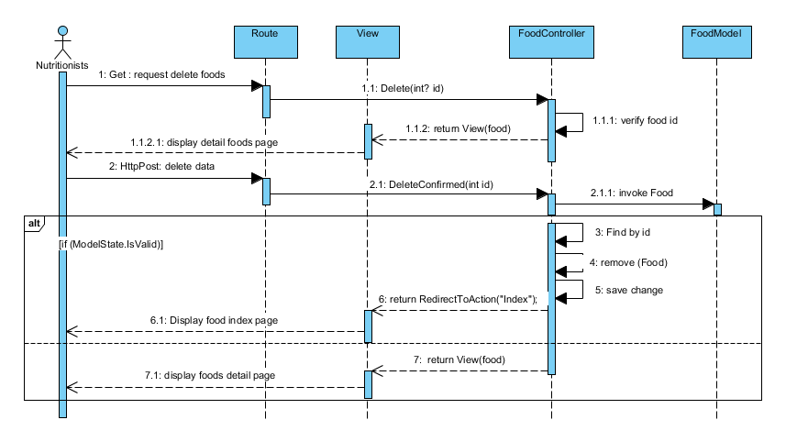

Figure 31: SD09: Delete food

# 4.3.2.10 SD10: Add activity

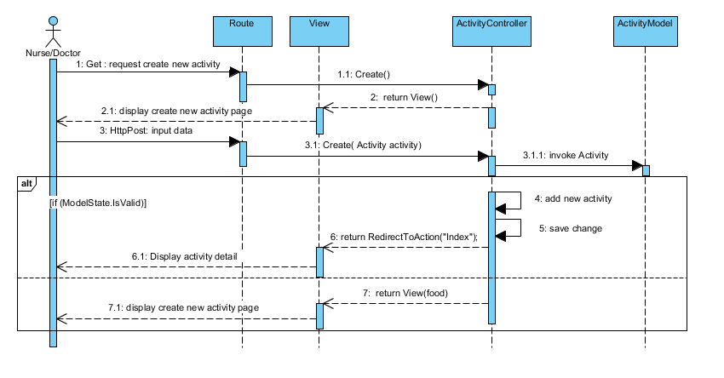

Figure 32: SD010: Add activity

# 4.3.2.11 SD11: Edit activity

# C:\Users\DELL\Desktop\project\diagram\sdsd\11.PNG

Figure 33: SD11: Edit activity

# 4.3.2.12 SD12: Delete activity

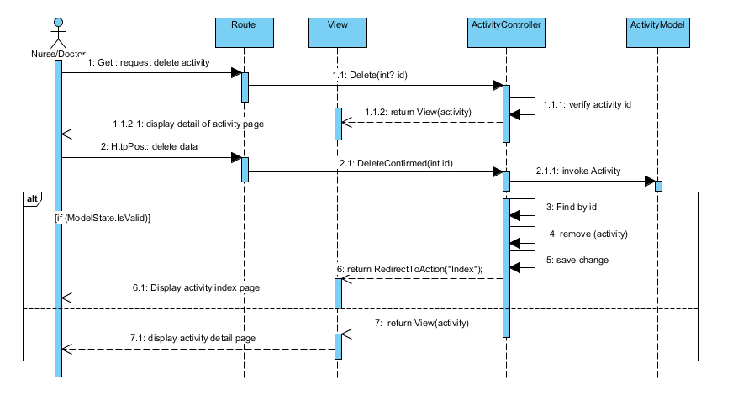

Figure 34: SD12: Delete activity

# 4.3.2.13 SD13: Admin create new user.

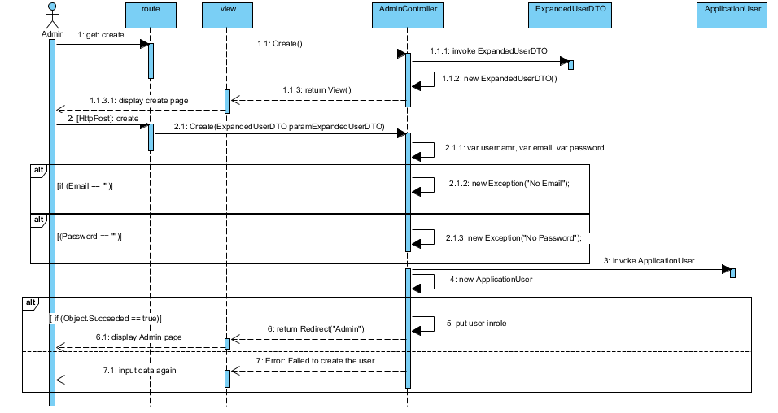

Figure 35: SD13: Admin create new user.

# 4.3.2.14 SD14: Admin edit user info.

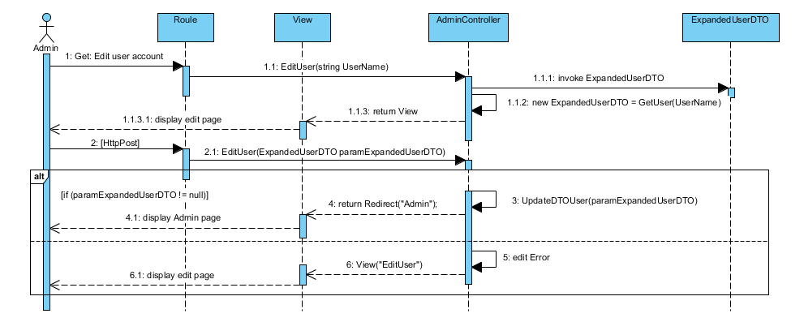

Figure 36: SD14: Admin edit user info.

# 4.3.2.15 SD15: Delete user

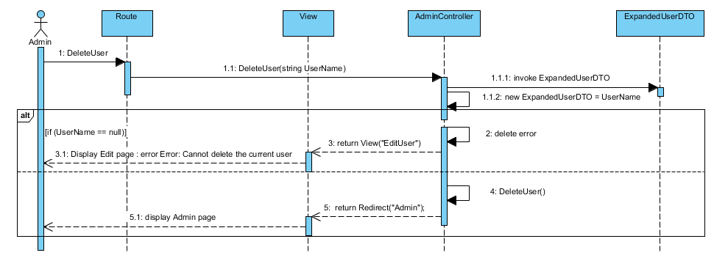

Figure 37: SD15: Delete user

# 4.3.2.16 SD16: Add food to health plan.

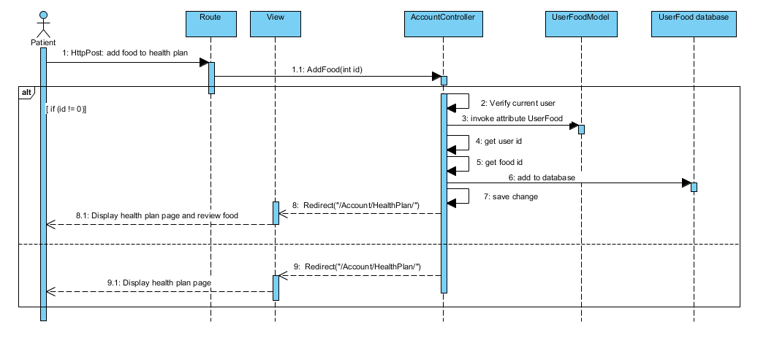

Figure 38: SD16: Add food to health plan.

# 4.3.2.17 SD17: Delete food from health plan.

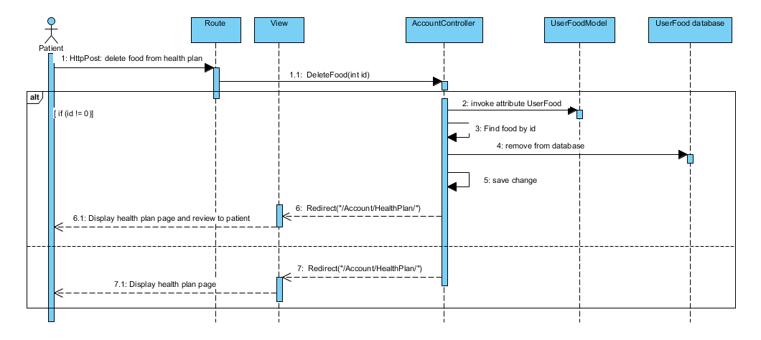

Figure 39: SD17: Delete food from health plan.

# 4.3.2.18 SD18: View BMI, BMR.

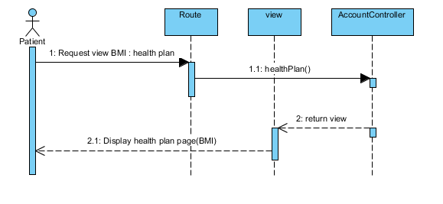

Figure 40: SD18: View BMI.

# 4.3.2.19 SD19: Add blood sugar.

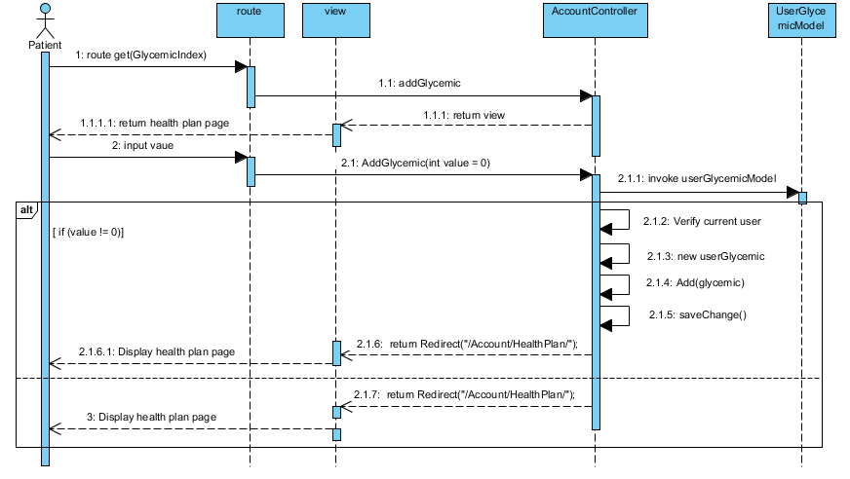

Figure 41: SD19: Add blood sugar.

# 4.3.2.20 SD20: View blood sugar on graph.

# C:\Users\DELL\Desktop\project\diagram\sdsd\20.PNG

# Figure 42:SD020: View blood sugar on graph.

# 4.3.2.21 SD21: Get recommend about blood sugar.

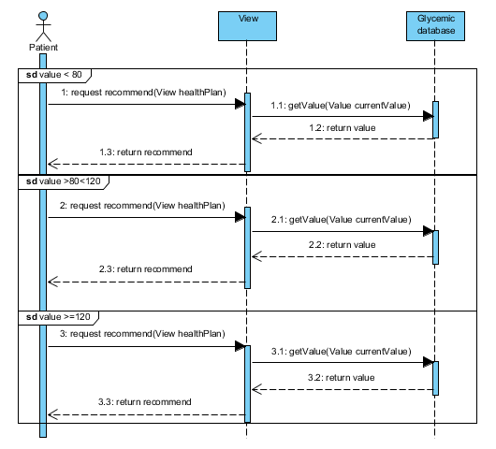Figure 43:SD021: Get recommend about blood sugar.

**4.3.3 User Interface.**

**4.3.3.1 Login**

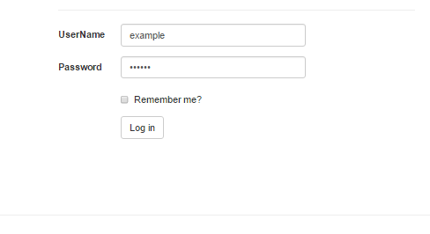

Figure 44:UI01: login.

**4.3.3.2 Logout**

**C:\Users\DELL\Desktop\project\diagram\logout.PNG**

Figure 45:UI02: logout.

**4.3.3.3 Registration**

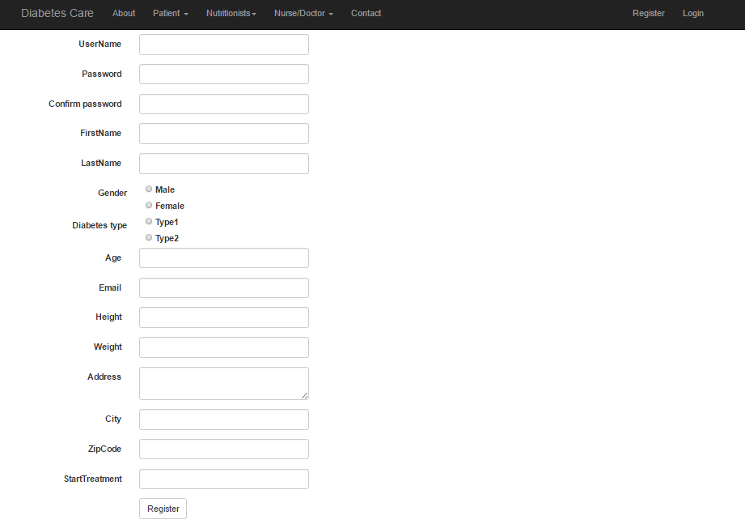

Figure 46:UI03: Registration.

**4.3.3.4 User profile.**

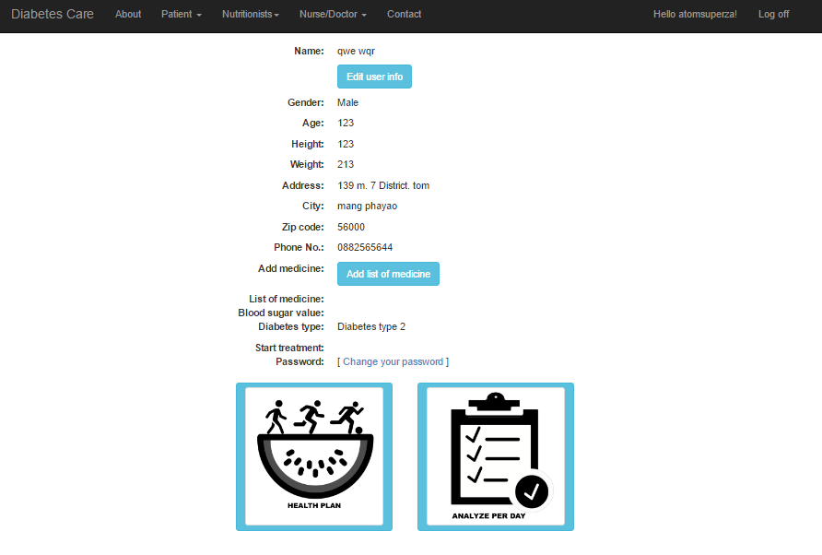

Figure 47:UI04: User profile.

**4.3.3.5 Edit user profile.**

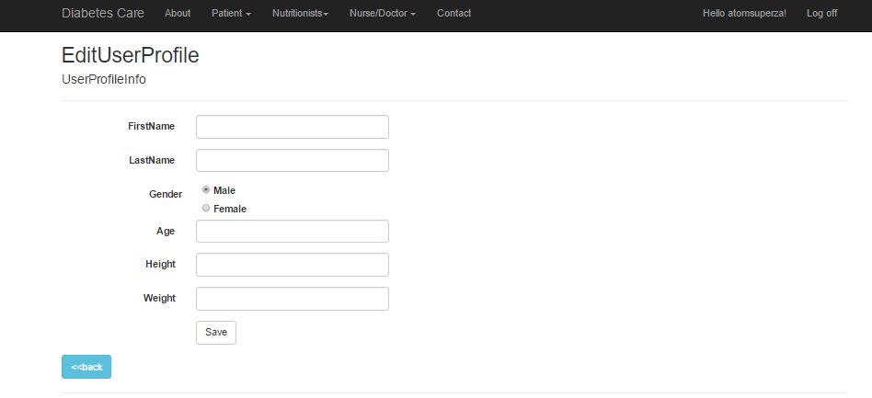

Figure 48:UI05: Edit profile.

**4.3.3.6 Change password.**

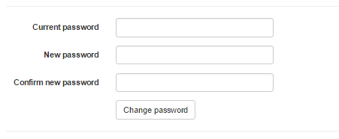

Figure 49:UI06: Chang password.

**4.3.3.7 Admin management page.**

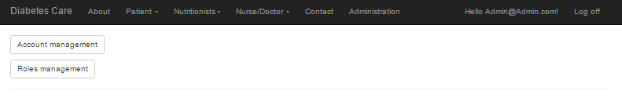

Figure 50:UI07: Admin management page.

**4.3.3.8 Admin manage account page.**

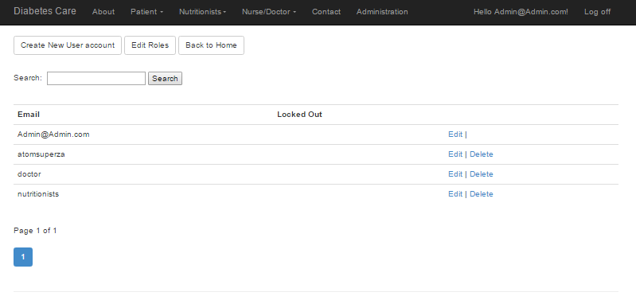

Figure 51:UI08: Admin manage account page.

**4.3.3.9 Create new food.**

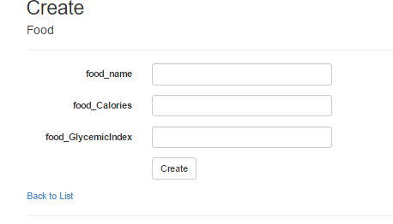

Figure 52:UI09: create new food.

**4.3.3.10 Edit food.**

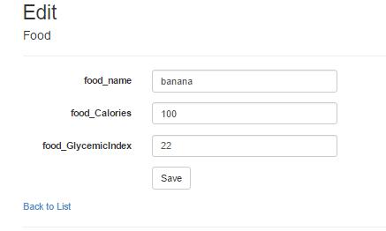

Figure 52:UI010: Edit food.

**4.3.3.11 Delete food.**

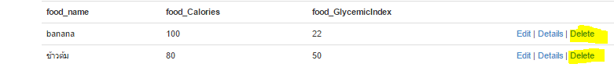

Figure 53:UI11: Delete food.

**4.3.3.12 Health plan page.**

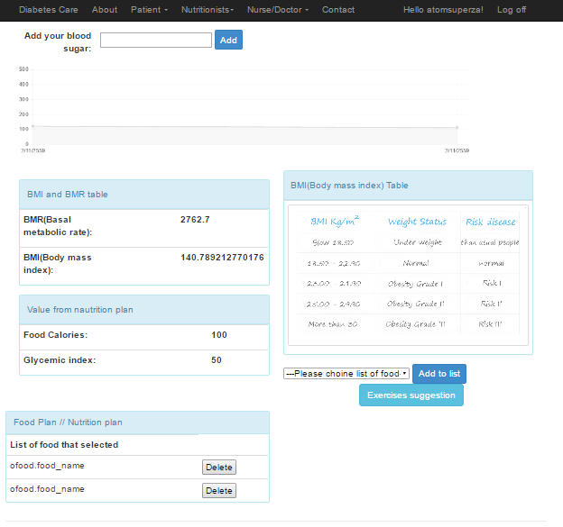

Figure 54:UI12: Health plan page.

**4.3.3.13 Exercise management.**

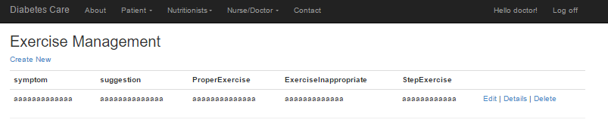

Figure 55:UI13: Exercise management.

**4.3.3.14 Exercise management creates new.**

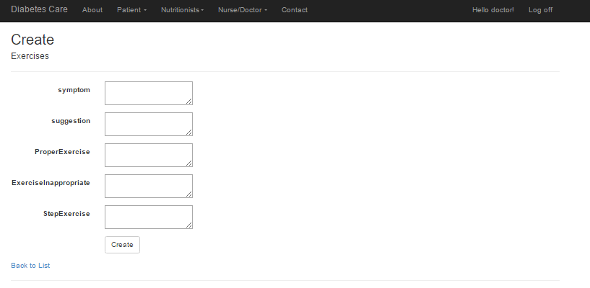

Figure 56:UI14: Exercise management creates new.

**4.3.3.15 Exercise management edits.**

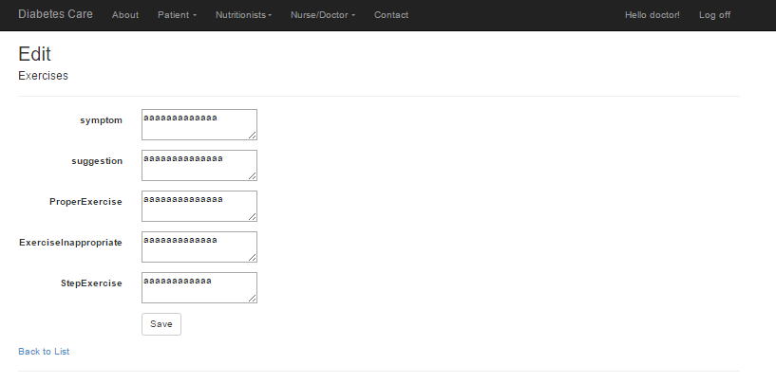

Figure 57:UI15: Exercise management edit.

**4.3.3.16 Exercise management deletes.**

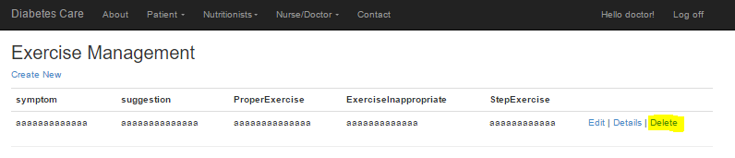

Figure 58:UI16: Exercise management delete.

**4.3.3.17 Behavior monitors system.**

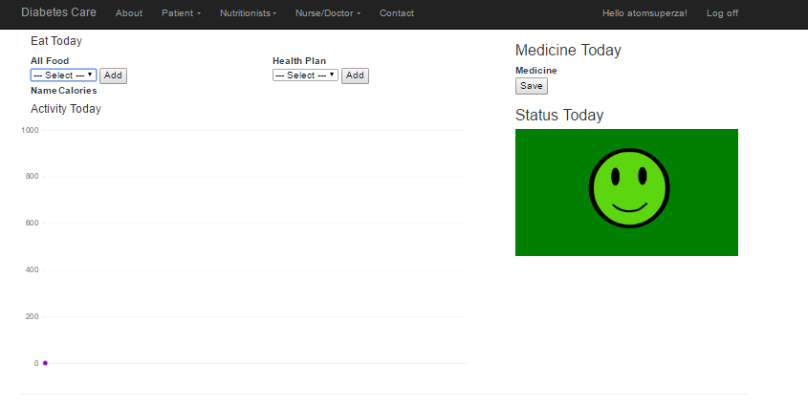

Figure 59:UI17: Behavior monitors system.

# Chapter Four | 4.4 Data Architecture

## 4.4.1 Entity Relationship Diagram

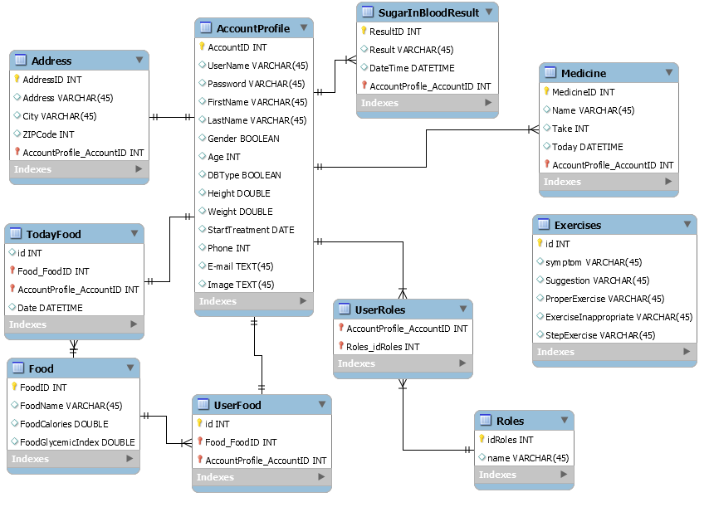

**Figure 60**: ER diagram

## 4.4.2 Database Design

### DB01 – AccountProfile

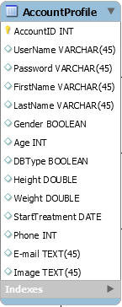

**Figure 61**: ER diagram: AccountProfile

**Class:** AccountProfile

**Description:** This table used for storing user’s information to the web application. **Attributes description:**

|  |  |  |  |
| --- | --- | --- | --- |
| **ID** | **Name** | **Description** | **Type** |
| 1 | AccountId | Stored user id number | int |
| 2 | username | Stored username of user | varchar |
| 3 | email | Stored user email | varchar |
| 4 | password | Stored user password | varchar |
| 5 | FirstName | Stored user first name | varchar |
| 6 | LastName | Stored user last name | varchar |
| 7 | Gender | Stored user gender | varchar |
| 8 | Age | Stored user age | int |
| 9 | DBType | Stored user diabetes type | boolean |
| 10 | Height | Stored user height | double |
| 11 | Weight | Stored user weight | double |
| 12 | StartTreatment | Stored user start treatment | DateTime |
| 13 | PhoneNo. | Stored user phone number | int |

**Table 20:** Description data of Class AccountProfile.

**DB02 – Address**

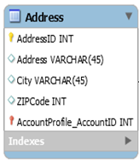

**Figure 62**: ER diagram: Address

**Class:** **Address**

**Description:** This table used for storing user’s address to the web application. **Attributes description:**

|  |  |  |  |
| --- | --- | --- | --- |
| **ID** | **Name** | **Description** | **Type** |
| 1 | AddressId | Stored user address id number | int |
| 2 | address | Stored address of user | varchar |
| 3 | city | Stored city of user | varchar |
| 4 | ZipCode | Stored the number of zip code | int |

**Table 21 :** Description data of Class Address.

**DB03 – Food**

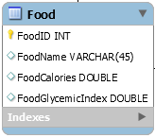

**Figure 63**: ER diagram: Food

**Class:** **Food**

**Description:** This table used for storing data of foods to the web application. **Attributes description:**

|  |  |  |  |
| --- | --- | --- | --- |
| **ID** | **Name** | **Description** | **Type** |
| 1 | foodID | Stored number of food id | int |
| 2 | FoodName | Stored the name of food on table “Food” | varchar |
| 3 | FoodCalories | Stored the calories of food on table “Food” | double |
| 4 | FoodGlycemicIndex | Stored the glycemic index of food on table “Food” | double |

**Table 22 :** Description data of Class Food.

**DB04 – Exercises**

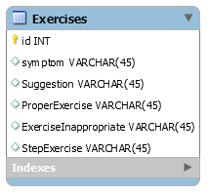

**Figure 64**: ER diagram: Exercises

**Class:** **Activity**

**Description:** This table used for storing data of activity to the web application. **Attributes description:**

|  |  |  |  |
| --- | --- | --- | --- |
| **ID** | **Name** | **Description** | **Type** |
| 1 | idactivity | Stored number of activity id | int |
| 2 | symptom | Stored the symptom of the body on table “Activity” | varchar |
| 3 | Suggestion | Stored the recommend from doctor about the exercise on table “Exercises” | varchar |
| 4 | ProperExercise | Stored the proper exercise on table “Exercises” | varchar |
| 5 | ExerciseInappropriate | Stored the exercise inappropriate on table “Exercises” | varchar |
| 6 | StepExercise | Stored the step exercise on table “Exercises” | varchar |

**Table 23:** Description data of Class Activity.

**DB05 – SugarInBloodResult**

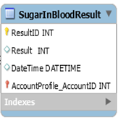

**Figure 65**: ER diagram: SugarInBloodResult

**Class:** **SugarInBloodResult**

**Description:** This table used for storing blood sugar value of user to the web application. **Attributes description:**

|  |  |  |  |
| --- | --- | --- | --- |
| **ID** | **Name** | **Description** | **Type** |
| 1 | ResultId | Stored id number of data | int |
| 2 | Result | Stored the value of blood sugar | int |
| 3 | DateTime | Stored date that user input data | DateTime |

**Table 24:** Description data of Class SugarInBloodResult.

**DB06 – Medicine**

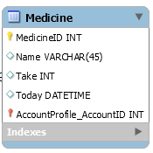

**Figure 66**: ER diagram:Medicine

**Class:** **Medicine**

**Description:** This table used for storing the medicine of user to the web application. **Attributes description:**

|  |  |  |  |
| --- | --- | --- | --- |
| **ID** | **Name** | **Description** | **Type** |
| 1 | MedicineID | Stored id number of data. | int |
| 2 | Name | Stored the name of medicine. | varchar |
| 3 | Take | Stored amount of medicine that user take in each day. | int |
| 4 | Today | Stored date that user take the medicine. | datetime |

**Table 25:** Description data of Class Medicine.

**DB09 – UserFood**

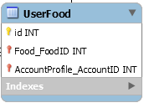

**Figure 67:** ER diagram : UserFood

**Class:** **UserFood**

**Description:** This table used for storing the id number of table food, accountProfile, and activity for syncing between class.

**Attributes description:**

|  |  |  |  |
| --- | --- | --- | --- |
| **ID** | **Name** | **Description** | **Type** |
| 1 | id | Stored id number. | int |
| 2 | Food_FoodID | Stored id number of food from table “Food” | int |
| 3 | AccountProfile_AccountID | Stored id number of user from table “AccountProfile” | int |

**Table 28:** Description data of Class Myplan

**DB09 – TodayFood**

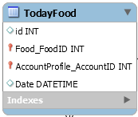

**Figure 68:** ER diagram : TodayFood

**Class:** **TodayFood**

**Description:** This table used for storing the id number of table food, accountProfile, and activity for syncing between class.

**Attributes description:**

|  |  |  |  |
| --- | --- | --- | --- |
| **ID** | **Name** | **Description** | **Type** |
| 1 | id | Stored id number. | int |
| 2 | Food_FoodID | Stored id number of food from table “Food” | int |
| 3 | AccountProfile_AccountID | Stored id number of user from table “AccountProfile” | int |
| 4 | Date | Stored date on table “TodayFood” | datetime |

**Table 28:** Description data of Class TodayFood

**DB09 – Roles**

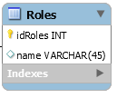

**Figure 69:** ER diagram : Roles

**Class:** **Roles**

**Description:** This table used for storing the id of roles and roles name.

**Attributes description:**

|  |  |  |  |
| --- | --- | --- | --- |
| **ID** | **Name** | **Description** | **Type** |
| 1 | id | Stored id number. | int |
| 2 | name | Stored id number of food from table “Food” | int |

**Table 28:** Description data of Class Roles

**DB09 – UserRoles**

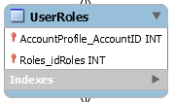

**Figure 70:** ER diagram : UserRoles

**Class:** **UserRoles**

**Description:** This table used for storing the id number of account from table “Account” and id of roles name from table “Roles”

**Attributes description:**

|  |  |  |  |
| --- | --- | --- | --- |
| **ID** | **Name** | **Description** | **Type** |
| 1 | accountProfile_AccountID | Stored id of user account from table “Account” on table “UserRoles” | int |
| 2 | Roles_idRoles | Stored id of roles name from table “Roles” on table “UserRoles” | int |

**Table 28:** Description data of Class UserRoles